Orion Inference Pipeline TDD

Architecture Design:
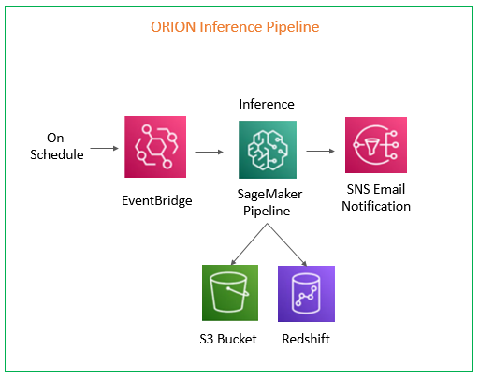
Description:
- Event Bridge triggers this pipeline once (Mon) per week. Then it invokes a dedicated step function which orchestrates all the other steps sequentially.
- Then Sagemaker Pipeline for Inference is executed and output is stored in s3 and Redshift.
- Once all this process is completed SNS Email Notifications are sent, if the workflow is success or failure.
Inference Sagemaker Workflow:
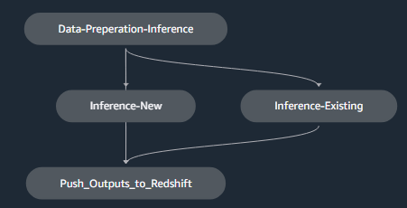
Description:
There are 4 python scripts used in this pipeline.
- data_prep_inference.py – Extracts data from SQL scripts and performs EDA
- Inference_new.py – Predictions for New Customers
- Inference_existing.py – Predictions for Existing Customers
- Write_to_redshift.py – Combines predictions of New & Existing Outputs and pushes to redshift tables.

AWS Services:
AWS Services Used | Name
Evenbridge Rule | Orion_Inference_Pipeline
Step Function | sagemaker-naf-orion-inference
Sagemaker Pipeline | orion-inference
SNS Topic | sagemaker-naf-orion

AWS Service | Customers | Input/Outputs | Paths
s3 | New | Inputs | s3://sagemaker-orion-dev/models/Current_Model_Outputs/new/
s3 | New | Outputs | s3://sagemaker-orion-dev/inference/outputs/inference-new/
s3 | Existing | Inputs | s3://sagemaker-orion-dev/models/Current_Model_Outputs/existing/
s3 | Existing | Outputs | s3://sagemaker-orion-dev/inference/outputs/inference-existing/
s3 | paths |  | s3://sagemaker-orion-dev/paths/inference_paths.json

Redshift Output Table Details:
Cluster | Schema | Inference output Table name
edl-redshift-analytics | user_reporting | orion_inference_outputs

Data Extraction Parameters:
Parameters | Values
run_week | Take from query
churn_cut_off_week | Take from query
Current_week | run_week
Offset | 0
Randomization | FALSE

